Plane and Solid

Definition
# Source: AI Source: Provided by: [Data Path: Persons Table -> ID Column: 1, Name_En Column: Motasem Essam] -> From: [ChatGPT] on [7/25/2026]
A plane–solid relationship describes how a plane is positioned relative to a three-dimensional solid, such as a cube, sphere, cylinder, cone, or pyramid. The plane may pass through the solid, touch its surface, separate part of the solid, or lie entirely outside it.
The relationship depends on the shape of the solid, the plane's position and orientation, and whether the plane intersects the solid's interior or only its boundary.
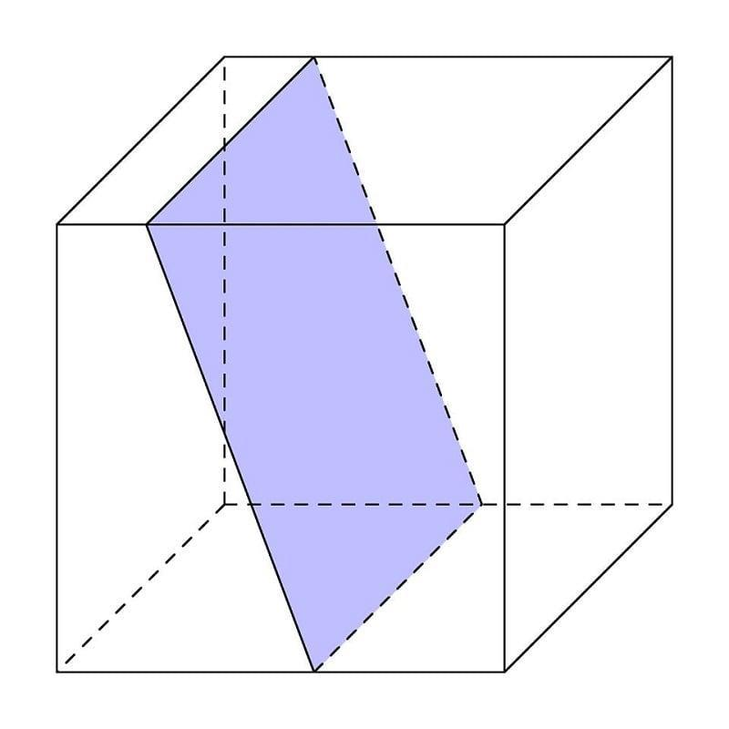
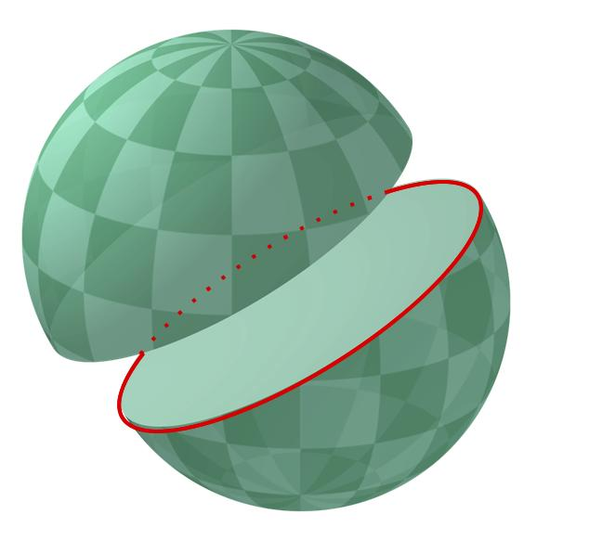
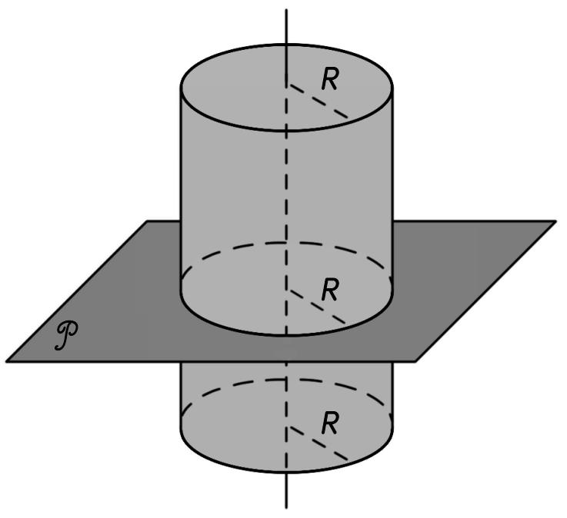

Simple Definition
# Source: AI Source: Provided by: [Data Path: Persons Table -> ID Column: 1, Name_En Column: Motasem Essam] -> From: [ChatGPT] on [7/25/2026]
Imagine a flat sheet passing near or through a three-dimensional object:
- If the sheet passes through the object, it intersects the solid.
- If the sheet touches the object without passing through its interior, it may be tangent to the solid.
- If the sheet is completely separated from the object, it does not intersect the solid.
- If the sheet cuts the object into parts, it creates a cross-section.

Key Characteristics
# Source: AI Source: Provided by: [Data Path: Persons Table -> ID Column: 1, Name_En Column: Motasem Essam] -> From: [ChatGPT] on [7/25/2026]
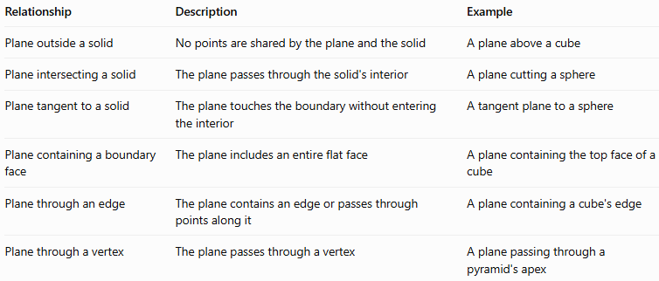
Relationship | Description | Example
Plane outside a solid | No points are shared by the plane and the solid | A plane above a cube
Plane intersecting a solid | The plane passes through the solid's interior | A plane cutting a sphere
Plane tangent to a solid | The plane touches the boundary without entering the interior | A tangent plane to a sphere
Plane containing a boundary face | The plane includes an entire flat face | A plane containing the top face of a cube
Plane through an edge | The plane contains an edge or passes through points along it | A plane containing a cube's edge
Plane through a vertex | The plane passes through a vertex | A plane passing through a pyramid's apex

Geometric Representation
# Source: AI Source: Provided by: [Data Path: Persons Table -> ID Column: 1, Name_En Column: Motasem Essam] -> From: [ChatGPT] on [7/25/2026]
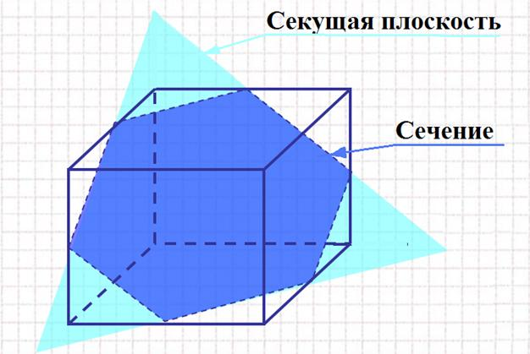
A plane can intersect different solids in different shapes. The shape formed where the plane cuts the solid is called a cross-section.

Common plane–solid configurations
# Source: AI Source: Provided by: [Data Path: Persons Table -> ID Column: 1, Name_En Column: Motasem Essam] -> From: [ChatGPT] on [7/25/2026]
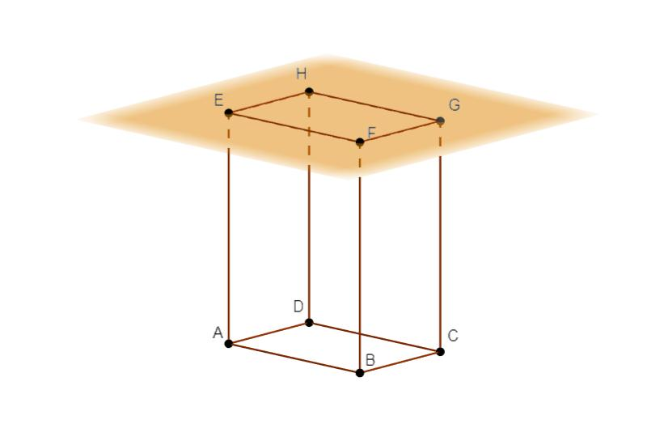
Outside
No shared points.
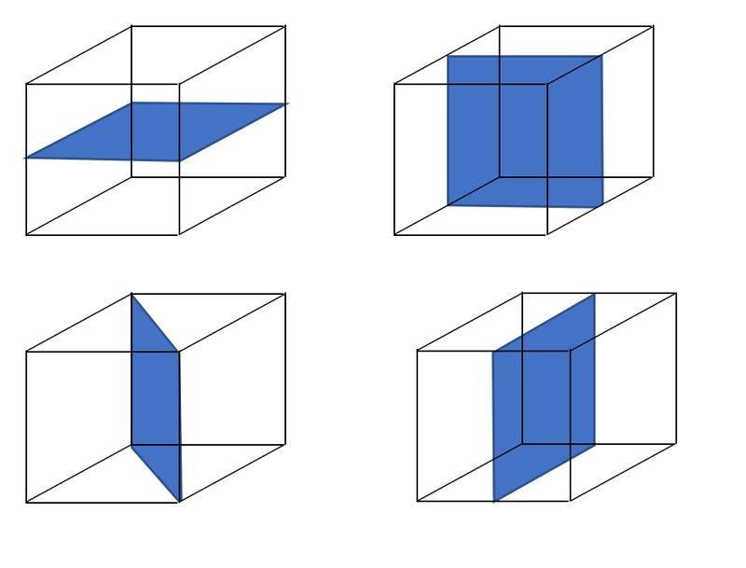
Intersecting
A cross-section is formed.
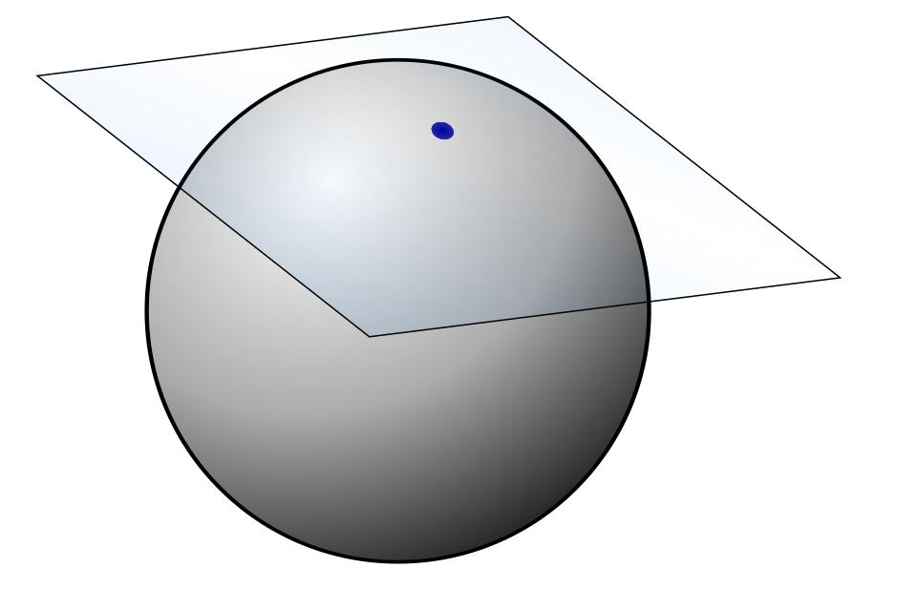
Tangent
Touches the boundary only.
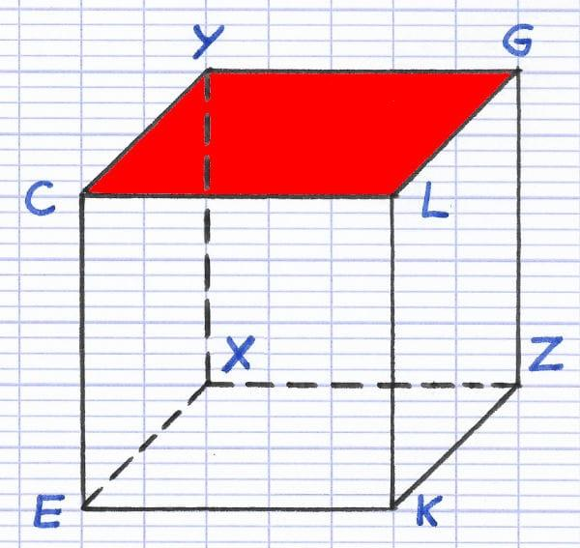
Containing a face
The plane includes a complete face.

Cross-sections of common solids
# Source: AI Source: Provided by: [Data Path: Persons Table -> ID Column: 1, Name_En Column: Motasem Essam] -> From: [ChatGPT] on [7/25/2026]
The cross-section depends on the solid and the orientation and position of the plane.
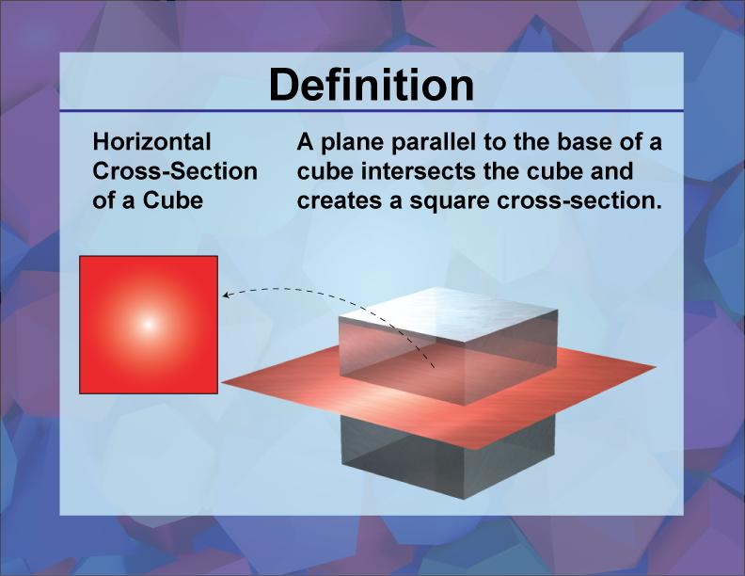
Cube
A plane parallel to a face produces a square cross-section. Other cuts can produce rectangles or other polygons.
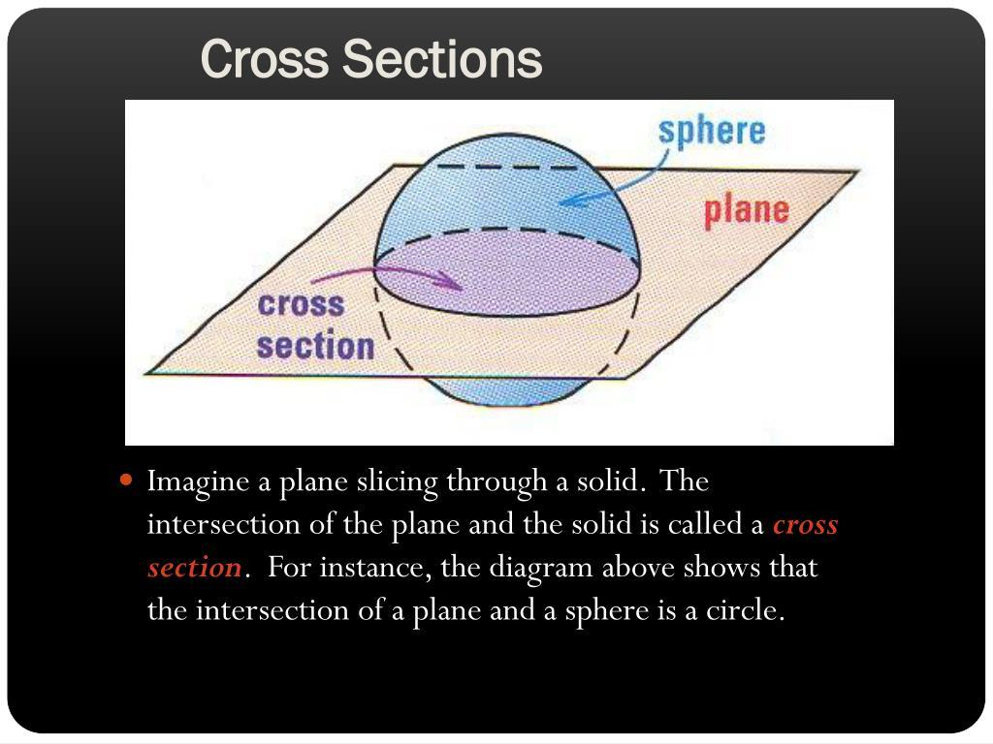
Sphere
Any plane that intersects the sphere produces a circular cross-section. A plane through the center produces a great circle.
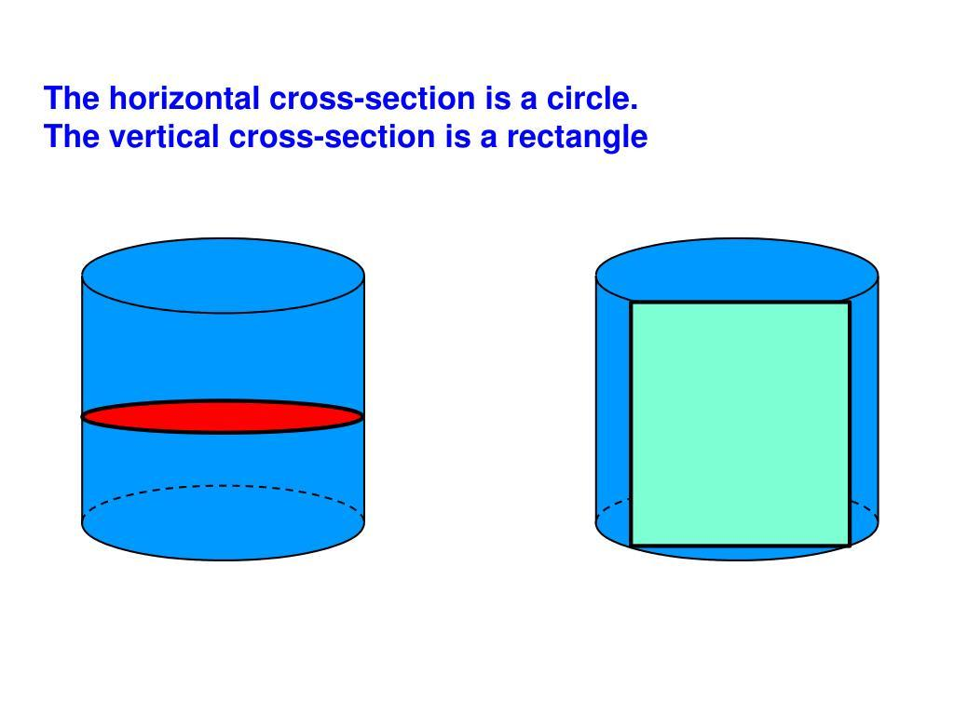
Cylinder
A plane parallel to the circular bases produces a circle. A plane parallel to the cylinder's axis can produce a rectangle when it cuts through the cylinder.
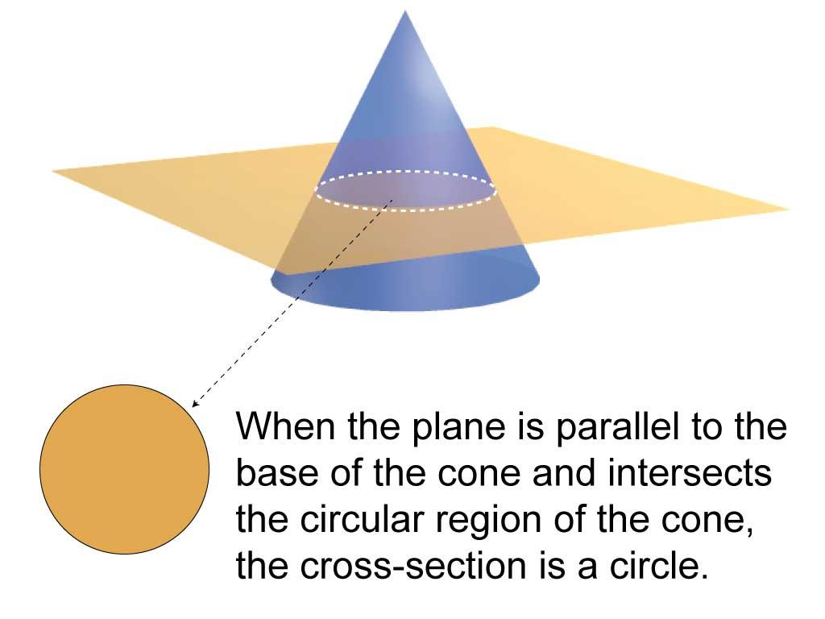
Cone
A plane parallel to the base produces a circular cross-section when it cuts the cone between its base and apex.

Mathematical Representation

Equation of a plane
# Source: AI Source: Provided by: [Data Path: Persons Table -> ID Column: 1, Name_En Column: Motasem Essam] -> From: [ChatGPT] on [7/25/2026]
A plane in three-dimensional Cartesian coordinates can be represented by
$$Ax+By+Cz+D=0$$
where $A$, $B$, and $C$ are not all zero.
A solid can be described by a set of points satisfying certain geometric conditions. The relationship between the plane and solid can be studied by checking which points belong to both.

Intersection of a plane and a solid
# Source: AI Source: Provided by: [Data Path: Persons Table -> ID Column: 1, Name_En Column: Motasem Essam] -> From: [ChatGPT] on [7/25/2026]
Let $S$ represent a solid and $P$ represent a plane. Their common points are represented by
$$S∩P$$
- If $S∩P=∅$, the plane and solid do not intersect.
- If the intersection consists of boundary points only, the plane may be tangent to the solid or coincide with part of its boundary.
- If the plane passes through the solid's interior, the intersection forms a cross-section.
Here, $∅$ means the empty set.

Plane–sphere relationship
# Source: AI Source: Provided by: [Data Path: Persons Table -> ID Column: 1, Name_En Column: Motasem Essam] -> From: [ChatGPT] on [7/25/2026]
For a sphere with center $\left(a,b,c\right)$ and radius $r$, the equation is
$${\left(x-a\right)}^{2}+{\left(y-b\right)}^{2}+{\left(z-c\right)}^{2}=r^{2}$$
For a plane $Ax+By+Cz+D=0$, the perpendicular distance from the sphere's center to the plane is
$$d=\frac{\left|Aa+Bb+Cc+D\right|}{\sqrt{A^{2}+B^{2}+C^{2}}}$$
Comparing $d$ with the sphere's radius $r$ determines the relationship:
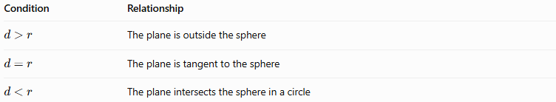
Condition | Relationship
$$d>r$$ | The plane is outside the sphere
$$d=r$$ | The plane is tangent to the sphere
$$d<r$$ | The plane intersects the sphere in a circle

Worked Examples
# Source: AI Source: Provided by: [Data Path: Persons Table -> ID Column: 1, Name_En Column: Motasem Essam] -> From: [ChatGPT] on [7/25/2026]
Example 1: A plane outside a sphere
Suppose a sphere has radius $3$ and center $\left(0,0,0\right)$. Consider the plane
$$z=5$$
The distance from the center to the plane is $5$, which is greater than the radius $3$.
Therefore, the plane does not intersect the sphere.
Example 2: A plane tangent to a sphere
Consider the same sphere with radius $3$, but now use the plane
$$z=3$$
The distance from the center to the plane is $3$, equal to the sphere's radius.
Therefore, the plane is tangent to the sphere at the point $\left(0,0,3\right)$.
Example 3: A plane intersecting a sphere
Consider the sphere
$$x^{2}+y^{2}+z^{2}=25$$
and the plane
$$z=0$$
Substituting $z=0$ into the sphere's equation gives
$$x^{2}+y^{2}=25$$
This is a circle of radius $5$ in the $xy$-plane. Thus, the plane cuts the sphere through its center and forms a great circle.
Example 4: A plane containing a face of a cube
Suppose a cube occupies the region
$$0≤x,y,z≤4$$
The plane $z=4$ contains the cube's entire top face, where $0≤x,y≤4$.
The intersection is a square with side length $4$ and area
$$A=4^{2}=16$$
The plane coincides with the supporting plane of that face.

Comparison With Related Concepts
# Source: AI Source: Provided by: [Data Path: Persons Table -> ID Column: 1, Name_En Column: Motasem Essam] -> From: [ChatGPT] on [7/25/2026]
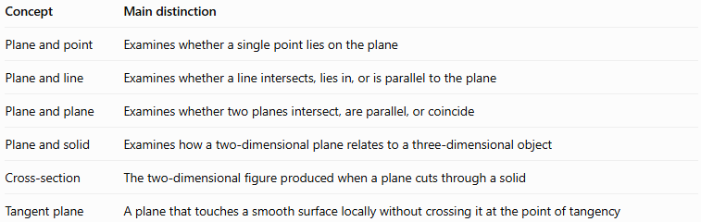
Concept | Main distinction
Plane and point | Examines whether a single point lies on the plane
Plane and line | Examines whether a line intersects, lies in, or is parallel to the plane
Plane and plane | Examines whether two planes intersect, are parallel, or coincide
Plane and solid | Examines how a two-dimensional plane relates to a three-dimensional object
Cross-section | The two-dimensional figure produced when a plane cuts through a solid
Tangent plane | A plane that touches a smooth surface locally without crossing it at the point of tangency

Applications
# Source: AI Source: Provided by: [Data Path: Persons Table -> ID Column: 1, Name_En Column: Motasem Essam] -> From: [ChatGPT] on [7/25/2026]
- Engineering and manufacturing: Determining how a cutting plane divides a three-dimensional component.
- Architecture: Understanding horizontal and vertical sections through buildings.
- Computer graphics: Rendering visible cross-sections and intersections between objects.
- Medical imaging: Understanding how tomographic slices represent internal structures.
- Geometry and measurement: Calculating the area and shape of cross-sections.
- CAD and 3D modeling: Creating section views and inspecting solid models.

Key Points
# Source: AI Source: Provided by: [Data Path: Persons Table -> ID Column: 1, Name_En Column: Motasem Essam] -> From: [ChatGPT] on [7/25/2026]
- A plane may be outside a solid, intersect it, touch its boundary, or contain one of its faces.
- A plane cutting through a solid forms a cross-section.
- Cross-section shapes depend on both the solid's geometry and the plane's orientation.
- For a sphere, the distance from its center to the plane determines whether the plane misses, touches, or intersects the sphere.
- A plane containing a face of a polyhedron is a special boundary case.
- These relationships help describe three-dimensional geometry precisely.

Conclusion
# Source: AI Source: Provided by: [Data Path: Persons Table -> ID Column: 1, Name_En Column: Motasem Essam] -> From: [ChatGPT] on [7/25/2026]
The plane and solid relationship describes the position and intersection of a flat, infinite plane relative to a three-dimensional object. It connects basic spatial geometry with cross-sections, tangency, surface boundaries, and mathematical calculations. Understanding these relationships makes it easier to analyze solids and their shapes in both theoretical and practical settings.

